# 5th Testing – 3rd May

Story 8: Open PDF File

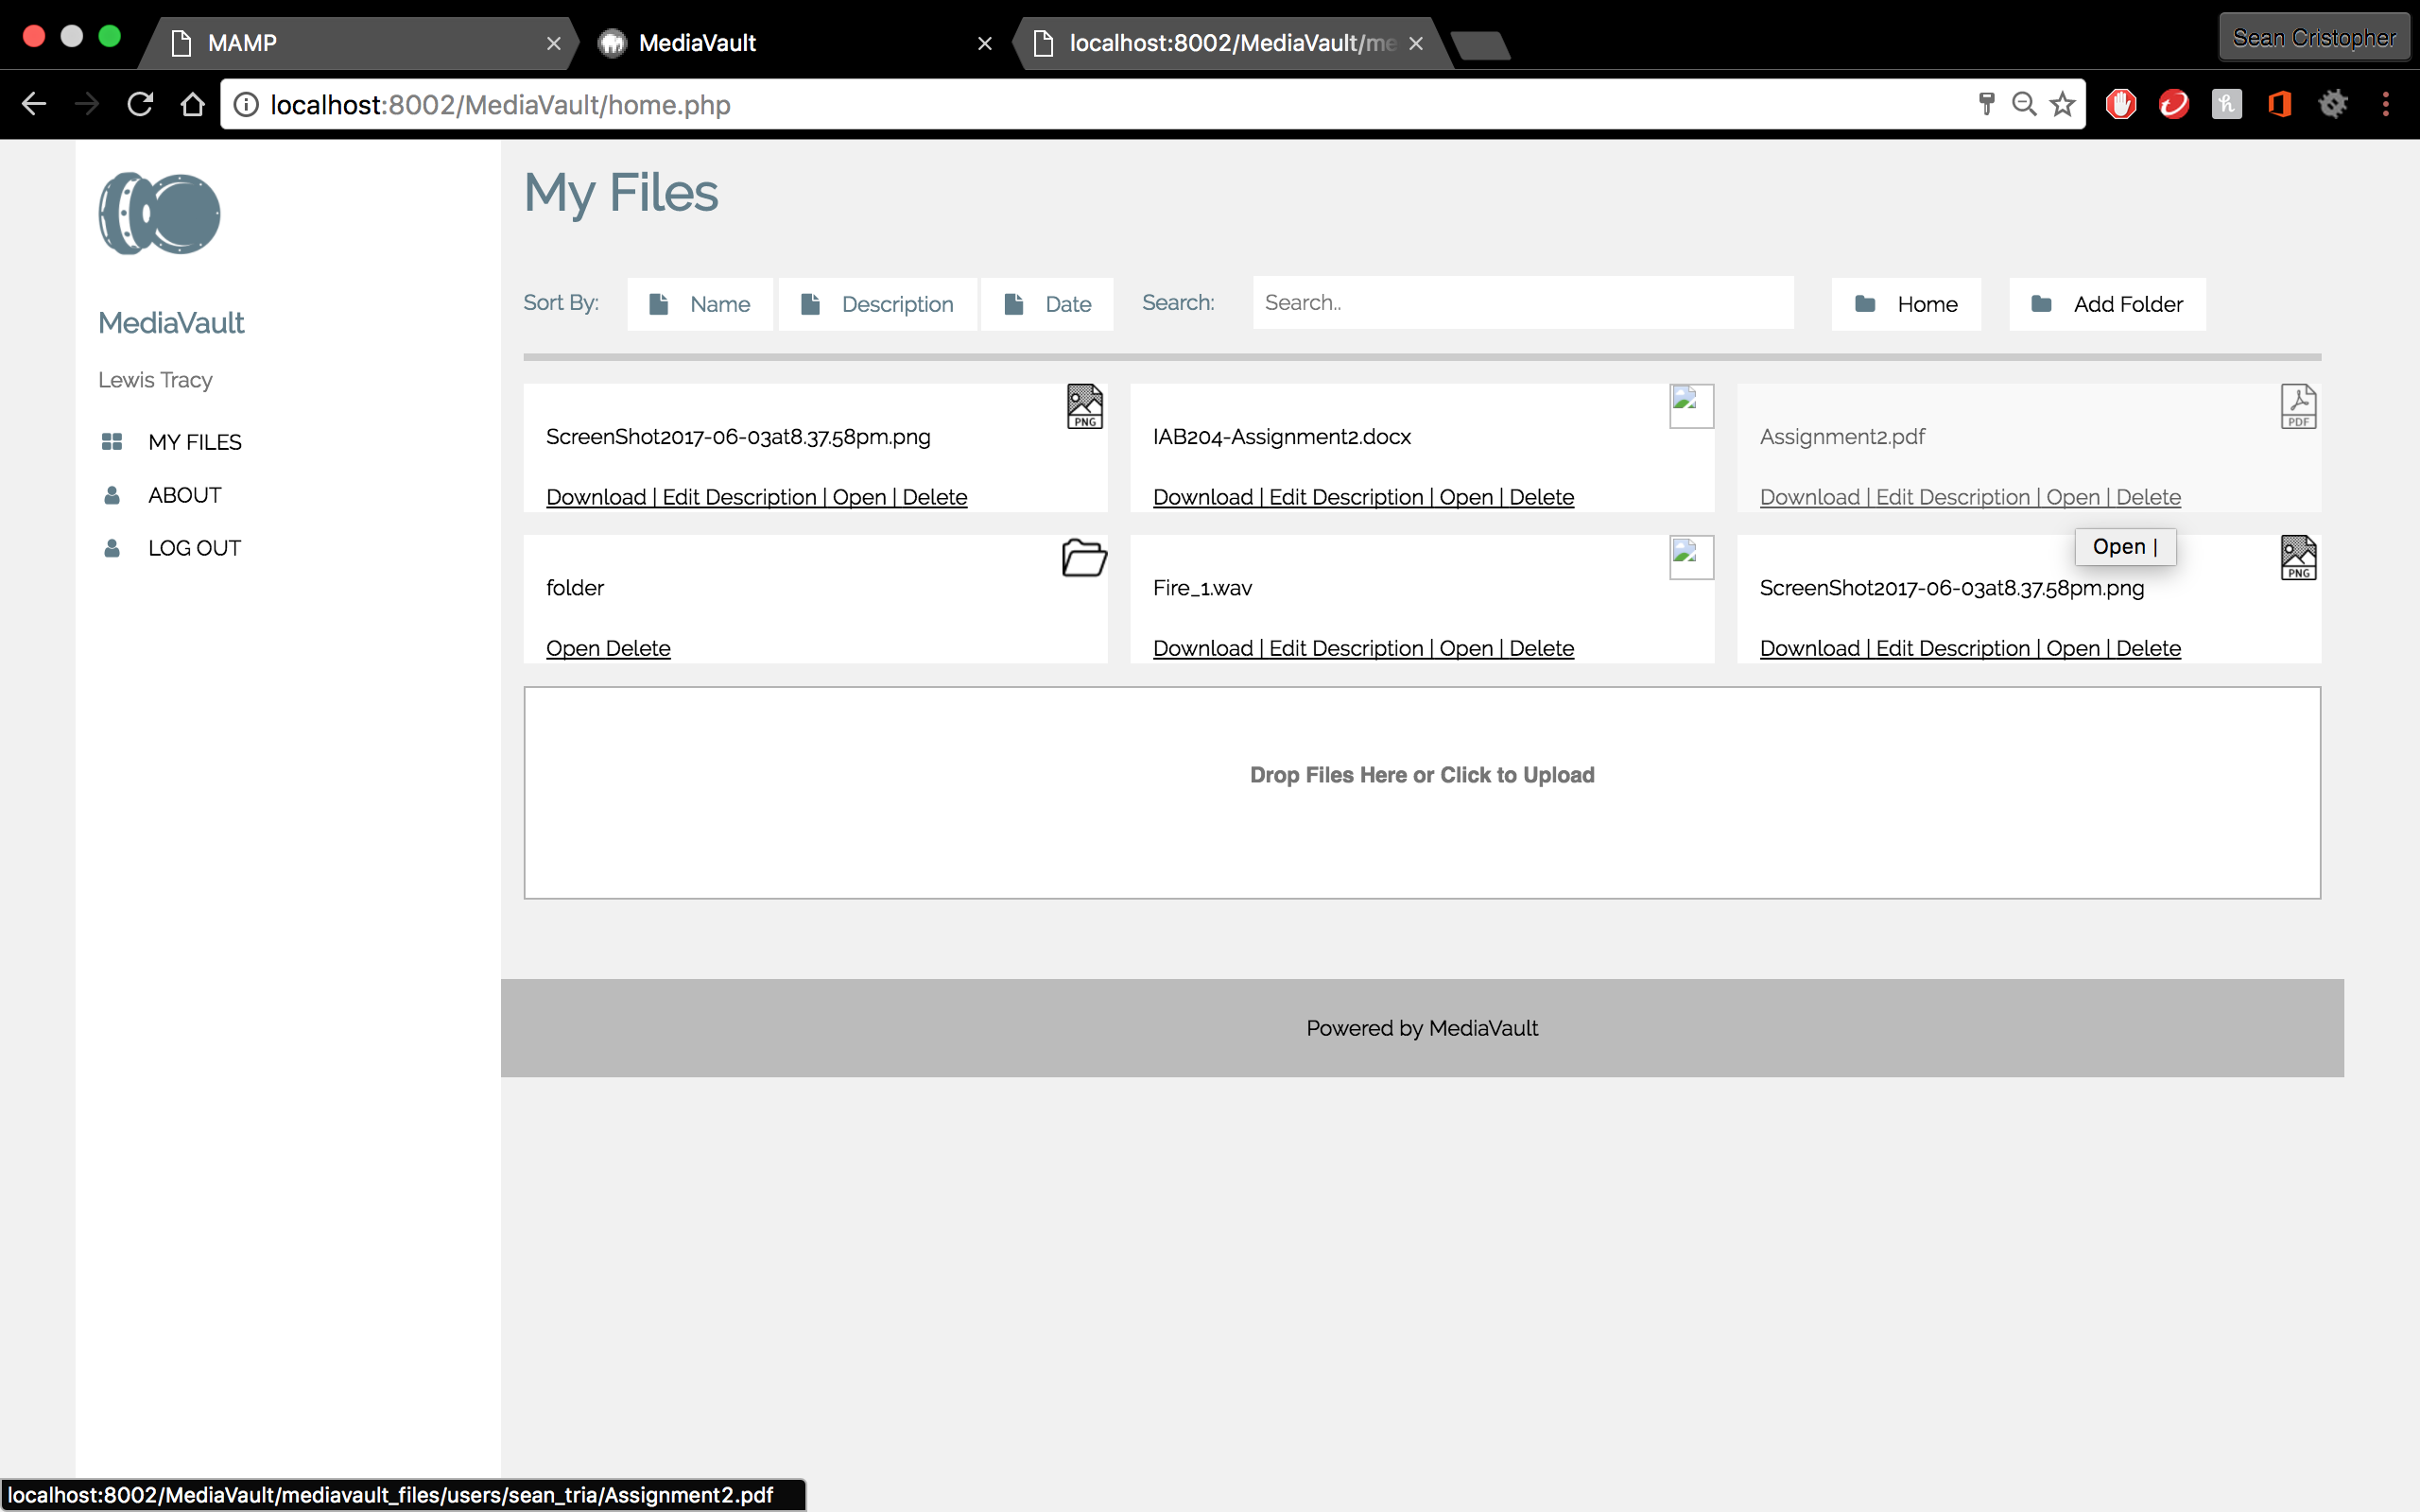 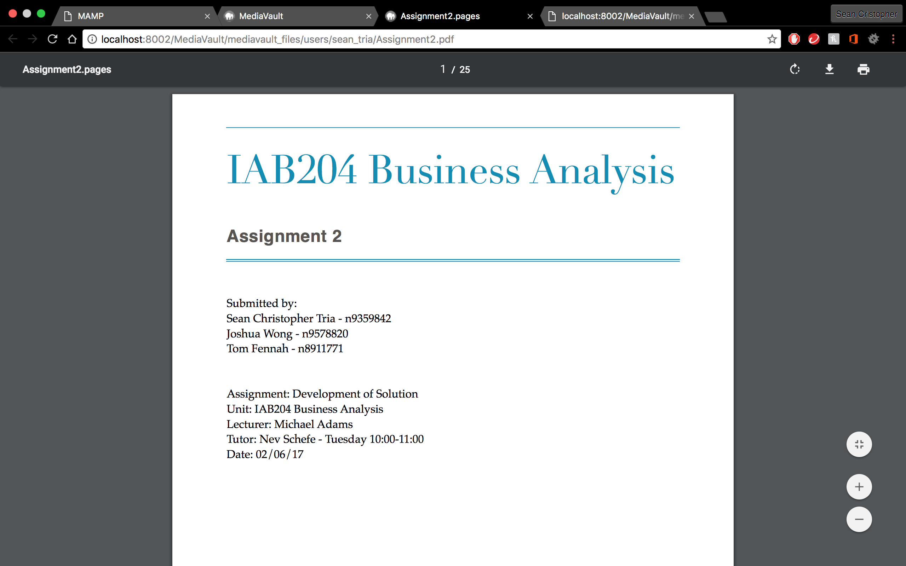

* “Open” button is independent for each file/folder
* PDF files successfully open on browser

Story 8B: Open my eBook File

 

* “Open” button is independent for each file/folder
* PDF files successfully open on browser

Story 9: Open my Audio File

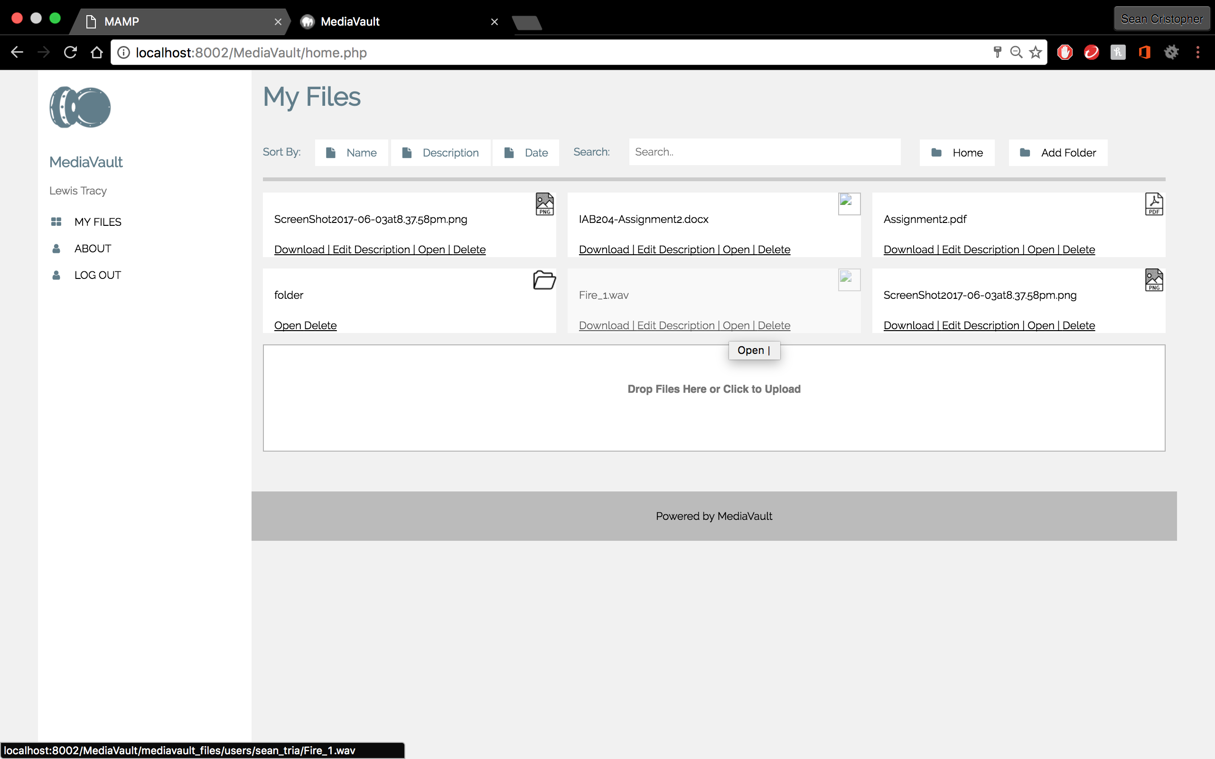 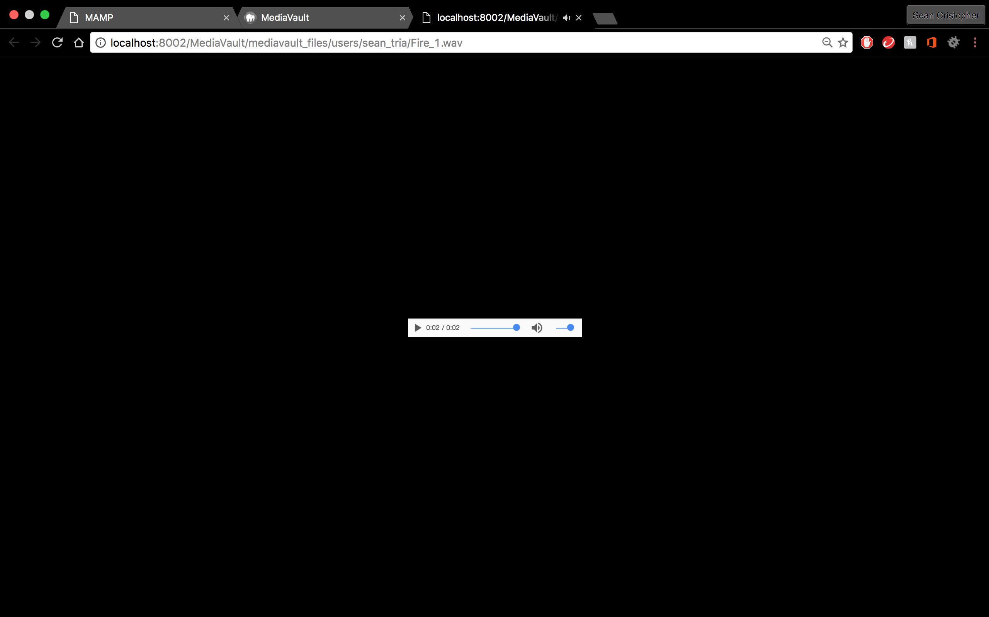

* “Open” button is independent for each file/folder
* Audio files successfully open on browser and plays

Summary: Initial testing for release 2 was successful. Every user story functions